# Plus HydraGlyde Multifocal

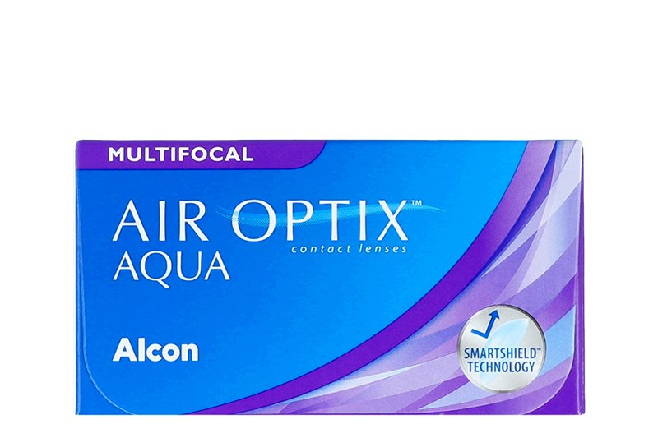

Product information

|  |  |
| --- | --- |
| **Brands** | Air Optix |
| **Availability** | In Stock |
| **Replacement** | Monthly |
| **Material** | 67% lotrafilcon B |

Description

**AIR OPTIX® plus HYDRAGLYDE MULTIFOCAL lenses are manufactured by Alcon (previously CIBA Vision). Eventually we are all affected by the vision problem known as presbyopia - the inability to focus on nearby visuals. From reading, to working on a computer, to driving, AIR OPTIX® plus HYDRAGLYDE MULTIFOCAL lenses provide smooth transitions as your eyes naturally move from one focal distance to another – near, intermediate and far.**